

Assessment 2: Software Development
Customer Case Support with AI Enhancements
-- Semester 1, 2026 --
IMPLEMENTATION REPORT

DECLARATION
“By submitting this assignment, we are aware of the University rule that students must not act in a manner that constitutes academic dishonesty, as stated and explained in the QUT Manual of Policies and Procedures.
We confirm that this work represents our efforts; we ALL have viewed the final version, which does not contain plagiarised material or content written through Generative AI.”

Canvas Group Number: 73
Task 6 Experience Site Link: https://orgfarm-24d134ad1d-dev-ed.develop.my.site.com/s
Student Name & Signature | Student ID | Tutor | Tutorial | Contribution % (must add up to 100%)
Minh Nguyen | N10794000 | Dr. Azumah Mamudu | Wednesday – 2pm to 4pm | [33⅓ %]
Fian Molanza | N11683449 | Dr. Azumah Mamudu | Wednesday – 2pm to 4pm | [33⅓ %]
Arianna Ciullo | N12656208 | Dr. Azumah Mamudu | Wednesday – 2pm to 4pm | [33⅓ %]

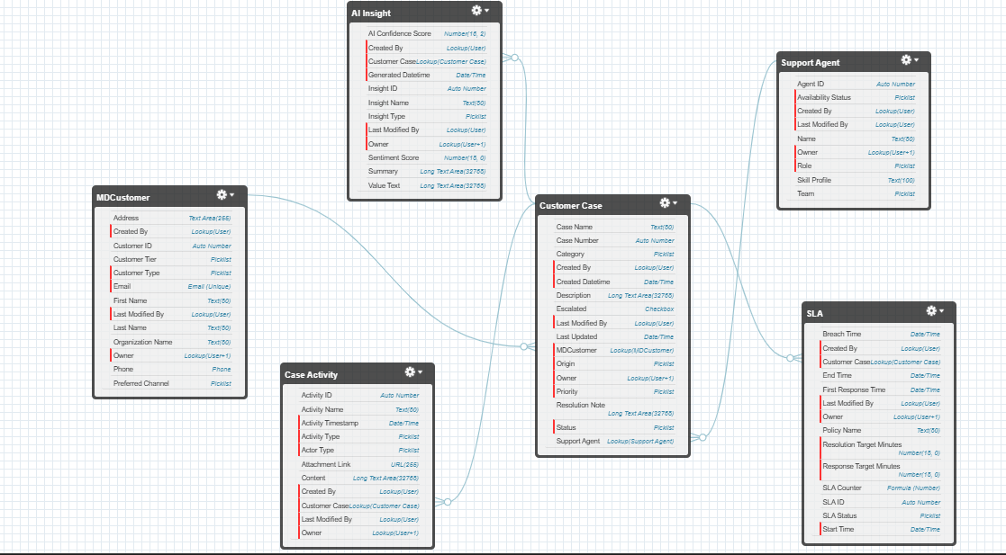
Task 1: Build a Data Model for the CCS+AI System

Description of Data Model Schema: The goal of MicroDesk Solutions is to capture the business objects upon which the CCS +AI System will operate and analyse “to facilitate planning and decision-making.” For this reason, the proposed Data Model Schema consists of:
Business Objects | Description | Required Attributes
MDCustomer | It represents the customers that interact with the system, either an individual or an organisation, by requesting support, reporting an issue, or sending an inquiry through a case.  All the personal information necessary to identify the customers is captured alongside a unique identifier, and other optional fields. | Customer ID  Personal details (First Name, Email, which is unique when possible, etc)  Customer Type  Organization Name (required if Customer Type = Organisation)
Support Agent | It represents MicroDesk’s internal users, so employees who are responsible for handling the cases.  Each agent has a unique identifier, their name (to identify them as well), a role (because if a case escalates, the resolution can go beyond their abilities and passes to a more expert agent), and an availability status. While a team (because cases can be handled better if each is divided into specific areas depending on the issue) and a skill profile are more optional. | Agent ID  Agent Name  Role  Availability status
Customer Case | It represents the reported issue, inquiry, or request for support that comes from the customer.  Each case has a unique identifier and captures other details important for the agent dealing with it. Such as, where was it originated from, the primary issue along with a summary, the status, a relation to the customer who generated it and priority.  Meanwhile, optional fields are category (so for which team is directed to), if it is escalated or not, when it was last updated, resolution notes and the current agent dealing with it. | Case ID  Case Name  Created Datetime (auto-set on creation)  Origin  Description  Status  Priority  MDCustomer (one-to-one relationship)
Case Activity | It stands for a follow-up of the interactions made on a case like comments, emails, or updates.  Each is connected to a unique customer case, they also own a unique identifier, and registers the activity type, when it occurred, who was the one to start or send it, the context and files attached as optional. | Activity ID  Activity Name  Activity type  Timestamp (when activity occurred)  Actor Type  Content  Customer Case (many-to-one relationship, where Customer Case is the parent class)
SLA | It is better conceived as the service level agreements between the agents and the customers to manage expectations and protect both parties from service failures.  Each is characterized by a name and can be accessed through a unique identifier that connects to the related case, it also describes the status of it, the target first response, the target resolution, and the SLA clock start.  The optional fields are the first response time, breach time and end time (when is resolved/closed). | SLA ID  Policy Name  Response Target Minutes  Resolution Target Minutes  SLA Status  Start Time (auto-set on creation)  Customer Case (one-to-one relationship typically, as it can also be one-to-many)
AI Insight | It would be “the AI-generated intelligence associated with a case.”  It is associated with a name, unique identifier, the type of the insight that will provide to the related case which could be a summary or a simple recommendation, the timestamp, and the AI rationale. While sentiment / confidence score for the AI generated insight is an optional field. | Insight ID  Insight Name  Insight Type  Generated Datetime  Value Text  Customer Case (one-to-one relationship, where Customer Case is the parent class)

Side Note:
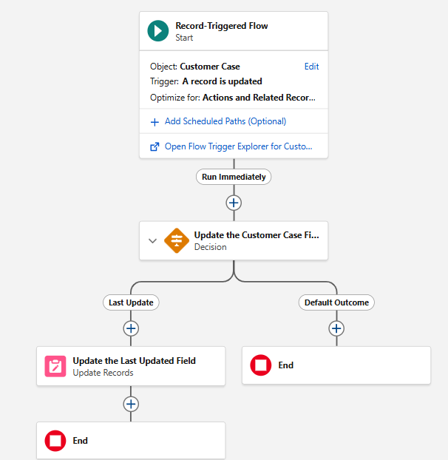
A Record-Triggered Flow was created for the field “Last Updated” of Customer Case, as when a case was created, a NOW() formula was used so it recorded the current time, but following subsequent updates it did not record the current time they were done.
So, when are Customer Case is updated, if the Last Updated field is less than the current time, gotten through a variable created of date type Date/Time and based on the formula NOW(), then the field Last Updated is updated. First, it filters the record, making sure the Record ID matches with the triggering record one, and then it sets the Last Updated field to the variable created with the current time.
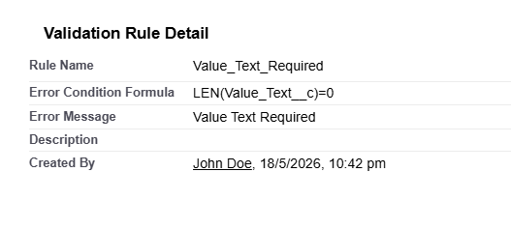
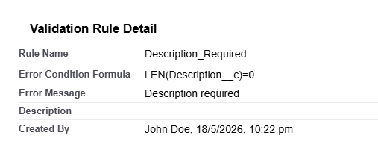
Since Description, in Customer Case, is data type Long text, which does not allow to set as “Required” the field, a validation rule stating that if nothing was written in it hits a snag was created to represent that. Same goes for Content, in Case Activity, and Value Text, in AI Insight.
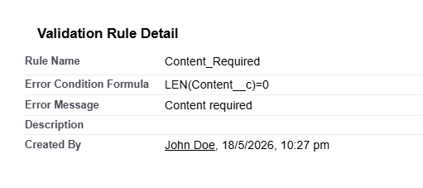

Task 2: Business Logic

SLA Tracking and Priority Management
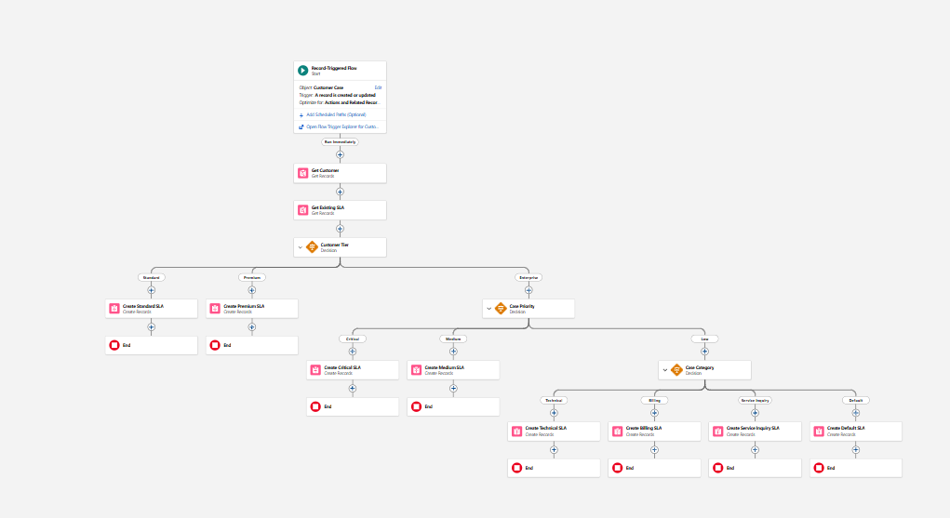
Description of 2(a): This is a Record-Triggered Flow that activates when a Customer Case is created, and it is optimized for “Actions and Related Records” so it runs after the case is saved in the database. It has the goal of assigning the appropriate SLA policy to the customer case depending on defined rules according to customer tier, case priority and case category. Firstly, MDCustomer records, where the customer must be the same one as the one that triggered the flow, are retrieved, and the evaluation for each rule is done through a Decision:
Customer Tier is analysed first, where it can either be Standard or Premium. Resolution and Response time (transformed in minutes) are settled as the Customer-Tier SLA Policy states on the case study alongside other rules such as Policy Name, which is set as a formula $Record.Case_Number__c & " SLA Policy" that returns a text that states the triggering customer case number + “SLA Policy” as the full policy’s name, Start Time set to CurrentDateTime and SLA Status set to “On Track”.
Same goes for Case Priority (applied for either Medium or Critical), Case Category (applies for either Billing, Technical or Service Inquiry) and lastly, a Default SLA if the rules do not apply for the triggering customer case.
---------------------------------------------------------------------------------------------------------------------------------

Priority-Based Auto-Routing
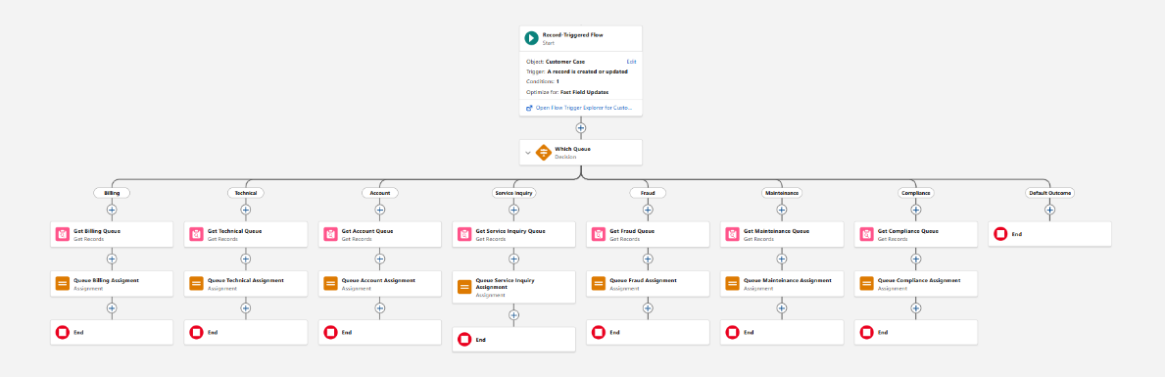

Description of 2(b): This is a Record-Triggered Flow that sets off when a Customer Case is created or updated, with the aim of assigning the case to their fitting support queue based on its category. Therefore, at the start, the entry condition is that Case Category must not be null and “Fast Field Updates” is selected to optimize the flow, allowing the fields on the record that activates the flow to be updated. Then, there is a Decision that functions like an if-statement, directing the case to its appropriate category- here, the condition that needs to be met is that the triggering case category corresponds to the branch category. Afterward, Get Records is used on Group, as Queues are stored as records in this object, and filtered for queue-type alongside the name for the proper support queue (the queue record data in stored in a record variable called Variable Queue by IDs). Lastly, Queue Assignment comes in, wherein the triggering case Owner ID becomes the support queue by assigning it the Variable Queue Group ID and, like that, finalising the flow.
---------------------------------------------------------------------------------------------------------------------------------

Case Status Update
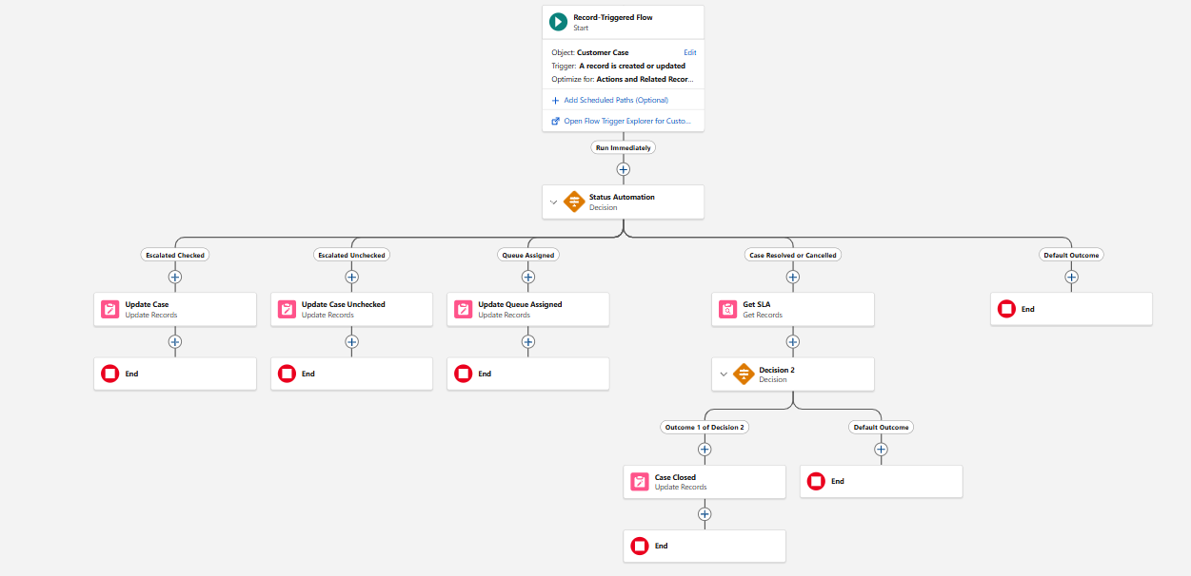
Description of 2(c): This is a Record-Triggered Flow that activates when a Customer Case is created or updated, and it is optimized for “Actions and Related Records” so it runs after the case is saved in the database. The aim of the flow is to automate the status of a case, reason why, a Decision is used to cover all the different scenarios: If the triggering customer case is escalated or not (checked or unchecked), if the triggering customer case is successfully assigned to a queue (the conditions settled evaluate if OwnerId is a Queue, through a formula LEFT({!$Record.OwnerId}, 3) = "00G" that checks if the 3 first characters of OwnerID equal to the prefix normally owned by queues, returning a Boolean, and that the triggering customer case’s OwnerID is not the same as prior customer cases’ OwnerID), and that if a customer case status is resolved or cancelled.
So, when a customer case is escalated (checked), Update records is used to change the customer case Status to “Escalated”. Instead, when customer case is not escalated (unchecked), Update records is used to change the customer case Status to “In Progress”. If the customer case is assigned to a queue, Update records is used to change the customer case Status to “In Progress”. Lastly, if a customer case is resolved or closed, the goal is to change the corresponding SLA Status to “Closed”, which is done by: Getting the SLA and verifying it is the one connected to the triggering customer case. Then, there is a Decision where the active branch assures the SLA ID is not null and proceeds to Update the SLA Status to “Closed” as well as setting the End Time to the current one when it closes.

Task 3: Data Validation

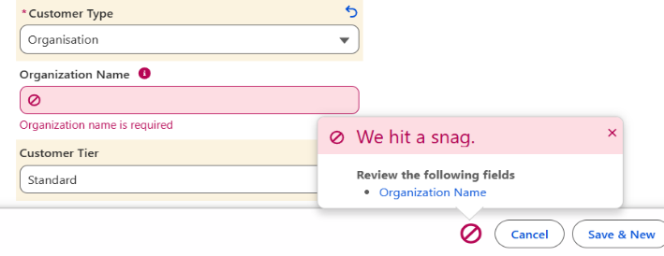
Organisation Name provision for organisational customers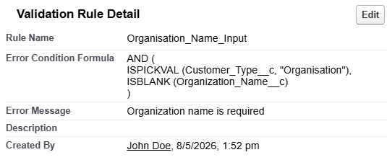

Description of 3(a): When creating or updating a Customer Case, a validation rule makes sure that if the customer type is an Organization and they do not enter the Organization name, when they try to Save it, it hits a snag requesting the Organization name “Organization name is required”. The formula uses an AND condition, where both statements need to be true, which are: The Customer Type (its data type is a picklist, reason why “ISPICKVAL” is used) needs to be an Organization and the field Organisation Name has to be blank (reason why “ISBLANK” was used).
---------------------------------------------------------------------------------------------------------------------------------

Enforcing Category value for critical cases
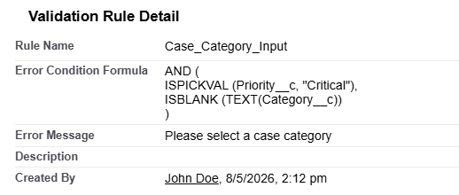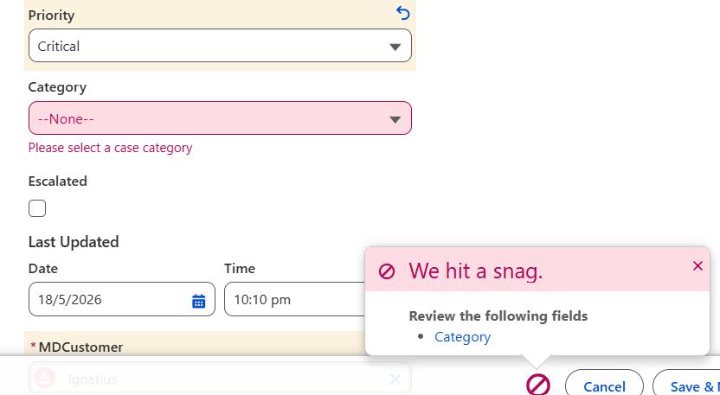
Description of 3(b): When creating or updating a Customer Case, a validation rule makes sure that if the priority of the case is “Critical”, the Category field must be chosen, if not, it produces an error and advices the user to choose it in order to proceed “Please select a case category”. The formula uses an AND condition, where both statements need to be true, which are: The Case Priority (its data type is a picklist, reason why “ISPICKVAL” is used) needs to be “Critical” and the field Category has to be blank (reason why “ISBLANK” was used, and Category’s data type is a picklist, so TEXT() is used to transform picklist’s values into text first).
---------------------------------------------------------------------------------------------------------------------------------

Prevent case being resolved if no resolution note provided
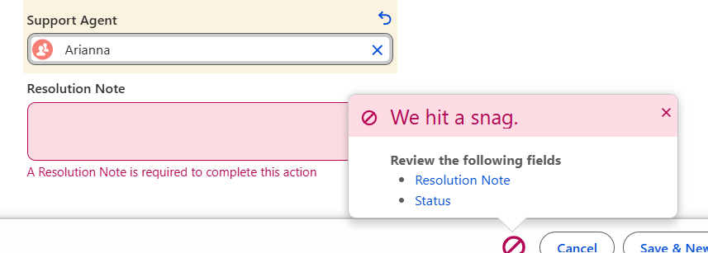
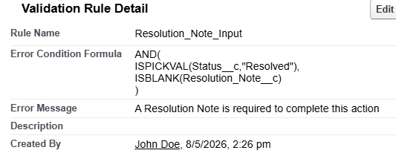
Description of 3(c): When creating or updating a Customer Case, a validation rule makes sure that if the customer case Status is set as “Resolved”, they cannot proceed as long as a Resolution Note is added “A Resolution Note is required to complete this action”. The formula uses an AND condition, where both statements need to be true, which are: The Customer Case Status (its data type is a picklist, reason why “ISPICKVAL” is used) needs to be “Resolved” and the field Resolution Note has to be blank (reason why “ISBLANK” was used).
---------------------------------------------------------------------------------------------------------------------------------

Case ‘Status’ update must adhere to given rules
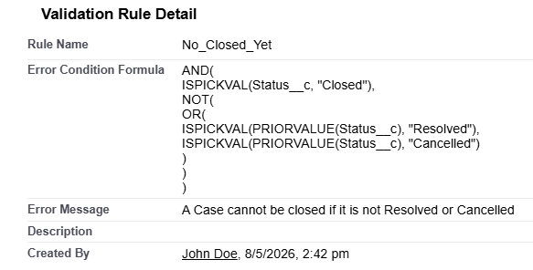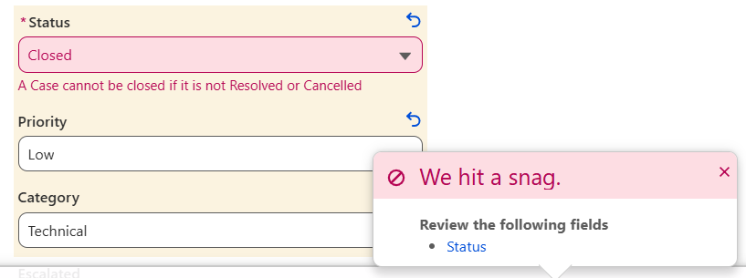
Figure 1
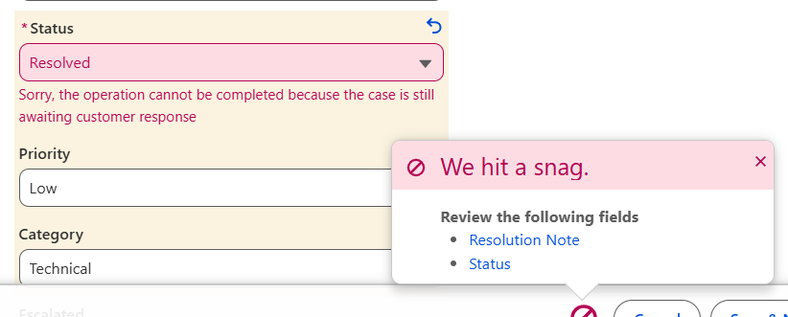
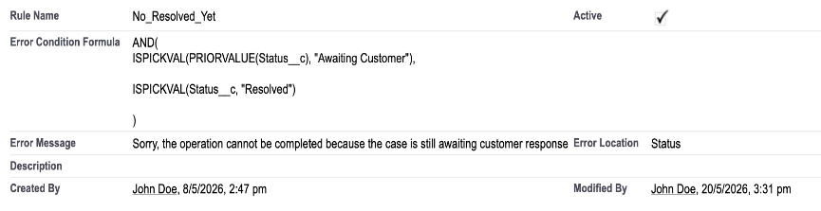
Figure 2
Description of 3(d):
- When updating a Customer Case, a validation rule checks, that if the customer case Status is set as “Closed”, the previously statuses must have been either “Resolved” or “Cancelled”, if not, then it hits a snag “A Case cannot be closed if it is not Resolved or Cancelled”. The formula uses an AND condition, where both statements need to be true, which are: The Customer Case Status (its data type is a picklist, reason why “ISPICKVAL” is used) needs to be “Closed” and then a NOT condition is used, stating that it cannot be neither of the outcomes, retrieved though an OR condition, where one of either conditions need to be true: “PRIORVALUE(Status__c)” is used to check if the previous value was either “Resolved” or “Cancelled” using “ISPICKVAL”.
- When updating a Customer Case, a validation rule checks, that if the user attempts to set the customer case Status as “Resolved” while the previous status is “Awaiting Customer”, then it produces an error “Sorry, the operation cannot be completed because the case is still awaiting customer response”. The formula uses an AND condition, where both statements need to be true, which are: The Customer Case Status (its data type is a picklist, reason why “ISPICKVAL” is used) needs to be “Resolved” and the PRIORVALUE(Status__c) of the picklist (reason why “ISPICKVAL” is used) needs to be “Awaiting Customer”.

Task 4: Workflow Automation

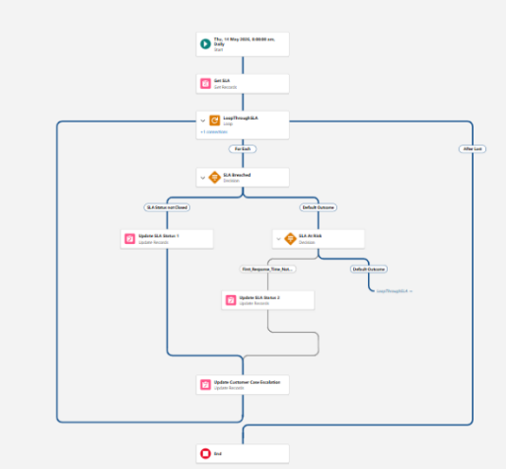
SLA Risk Monitoring Workflow
Description of 4(a): The flow begins by querying all non-closed SLA__c records and storing them as a collection, which is then traversed sequentially via a loop, assigning each record to {!LoopThroughSLA} per iteration. Each record undergoes a priority-based evaluation. It is first assessed for a Breached status — where SLA_Counter__c has met or exceeded Resolution_Target_Minutes__c while still open — and if not, evaluated as At Risk through a compound Boolean check combining conditions 1 or 3 with condition 2. Where either condition is met, the record's status fields are updated and Escalated__c is set to true. Records satisfying neither condition are skipped, and once all records have been processed, the flow concludes at the End element.
---------------------------------------------------------------------------------------------------------------------------------

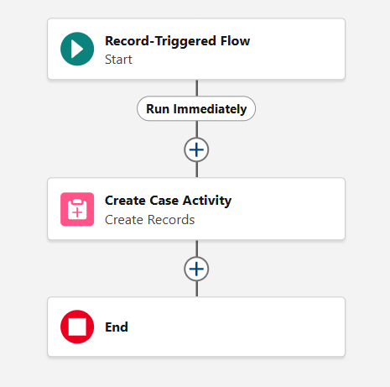
Escalation Management Workflow
Description of 4(b): This is a Record-Triggered Flow that activates when a Customer Case is updated, more specifically when the Escalation flag is checked, and it is optimized for “Actions and Related Records” so it runs after the case is saved in the database. The goal of the flow is to run automatically when a Customer Case is updated and meets that condition requirement, so it can create a Case Activity related to it and with specific set field values such as, Customer Case à Triggering Case Record ID, Activity Type à Status Change, Actor Type à Agent, and Content à a Text Template where:
“Status Change: Case Escalated
The Escalated flag was set to True by {!$Record.MDCustomer__r.Name} on {!$Record.Last_Updated__c} This action indicates that the case requires urgent attention. Escalation procedures have been triggered.”
---------------------------------------------------------------------------------------------------------------------------------

Automatic Notification Workflow
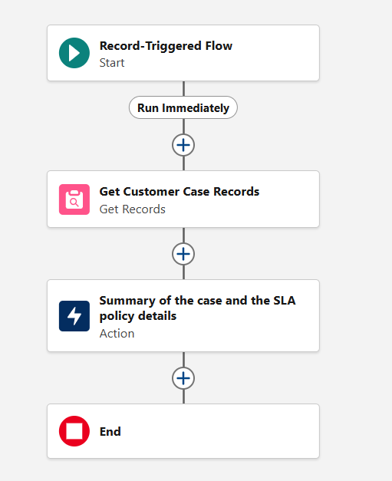
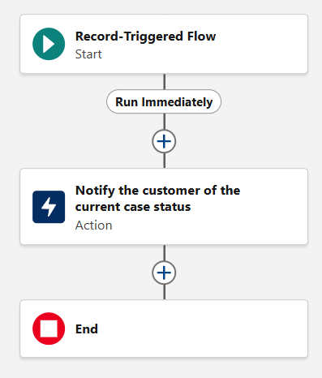
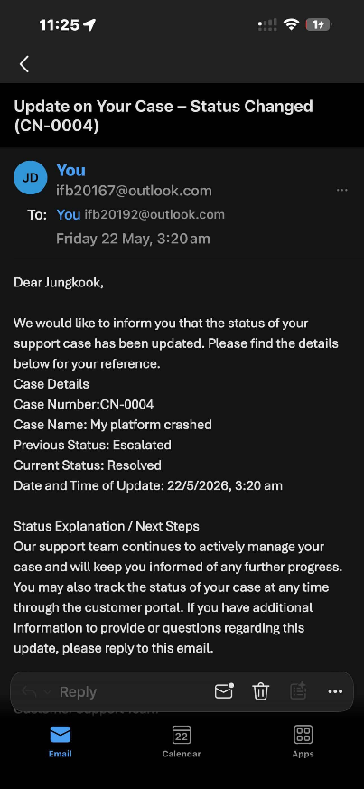
Figure 1
Figure 2
Example for Figure 2

Description of 4(c):
- This is a Record-Triggered Flow that activates when a SLA record is created or updated, and it is optimized for “Actions and Related Records” so it runs after the case is saved in the database. The goal is that whenever the flow is triggered it must sent the customer a notification about the case and SLA policy details. So, first the Customer Case records are retrieved where the Record ID must be the same as the customer case related to the triggering SLA record. Then the email is sent to the customer that created the case related to the triggering SLA record, where the Subject is a Text Template à “Your Case SLA Details – {!Get_Customer_Case_Records.Case_Number__c}” and the Body is the one provided in the case study but with the Case details changed accordingly to the retrieved one and the SLA policy ones accordingly to the triggering record.
- This is a Record-Triggered Flow that activates when a Customer Case record is updated, more specifically when its Status is changed, and it is optimized for “Actions and Related Records” so it runs after the case is saved in the database. The goal is that every time the record is updated and meets the condition imposed, then the flow sends an email to the customer linked to the triggering case to notify them of the current case status. The subject is a Text Template where à “Update on Your Case – Status Changed ({!$Record.Case_Number__c})” and the Body is the one provided in the case study but with the Case details changed accordingly to the triggering record. Though, one detail is the Previous Status, which is a formula that provides a text as an output which retrieves the previous status through “PRIORVALUE({!$Record.Status__c})”.

Task 5: Agentic AI Development + Enhancement

AI Insight Generation and Case Sentiment Scoring
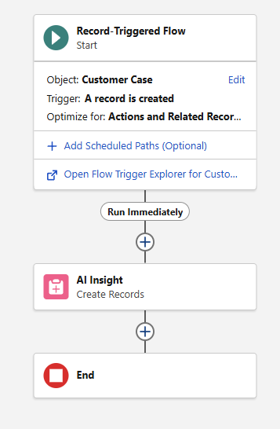
Description of 5(a): The AI Insight Generation flow was implemented as a Record-Triggered Flow in Salesforce that activates whenever a new Customer Case is created. The purpose of the flow is to automatically generate an AI Insight record linked to the created customer case.
The flow analyses the customer’s case description and creates an AI Insight containing generated sentiment-related information such as the insight type, generated datetime, summary, sentiment score, AI confidence score, and value text. The AI Insight record is automatically linked to the triggering Customer Case using the record ID relationship.
---------------------------------------------------------------------------------------------------------------------------------

Case Closure Summary Generator
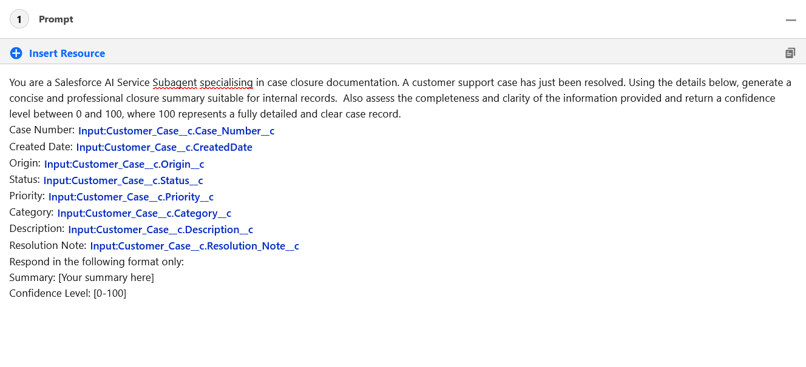
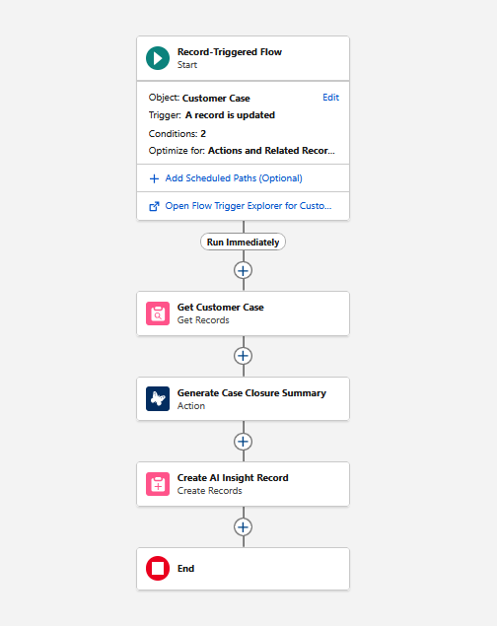
Description of 5(b): When a Customer Case Status is updated to Resolved, the Record-Triggered Flow fires and passes the triggering case record into a Core Action that calls the Case Closure Summary Prompt Template directly. The Prompt Template feeds all relevant case fields, including Case Number, Origin, Status, Priority, Category, Description, and Resolution Note into the Agentforce Agent, which generates a professional closure summary and confidence level returned as a single Prompt Response. The Flow then takes that response and creates a new AI Insight record of type Summary, storing the generated text in the Value Text field, linking it back to the originating Customer Case via the Record ID, and naming it using the format CN-XXXX Activity on: datetime.
---------------------------------------------------------------------------------------------------------------------------------

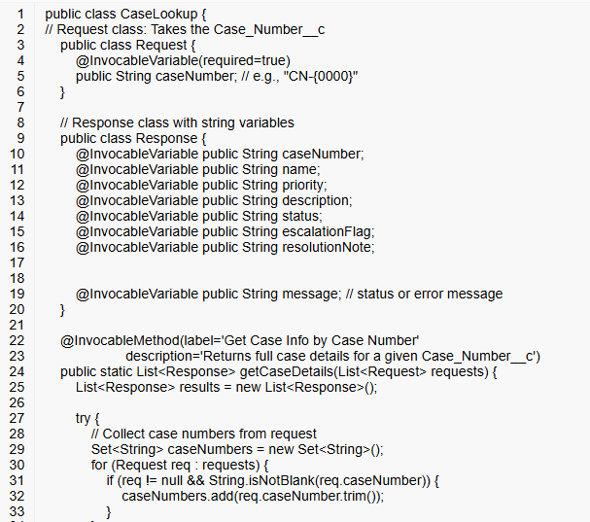
Customer Case Details Retrieval
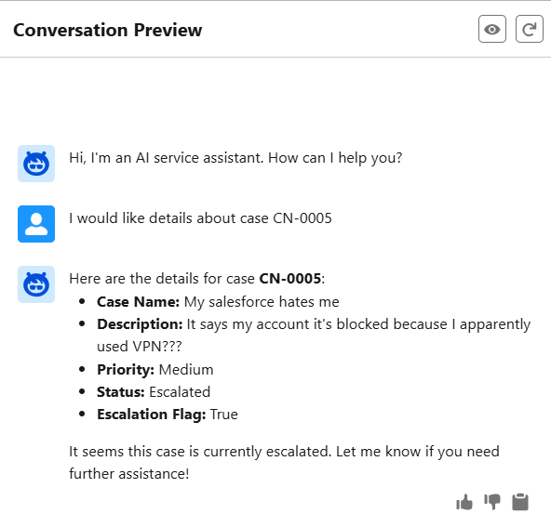
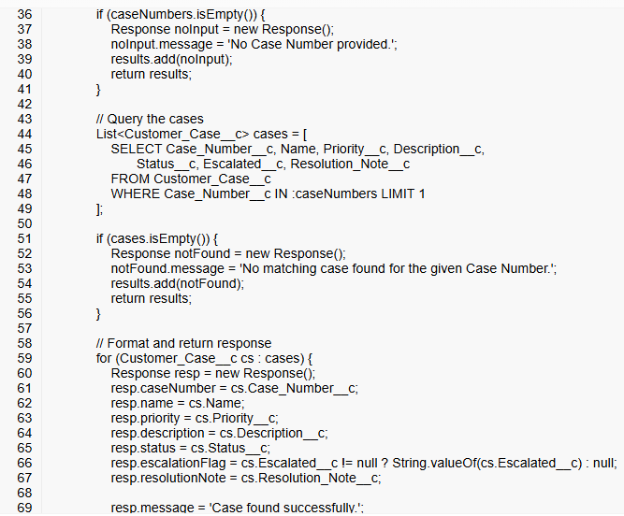

Description of 5(c): The goal of the MicroDesk Service Agent, in this case, is to retrieve and display case details based on a user-provided case number. If the user has not provided a case number, it asks them to do so. And, it does not handle inquiries outside the scope of case lookup. For the agent to do this, an Invocable Method was created to retrieve the case number, display the details and catching possible exceptions. Then, the method was added as an action and assigned as a new topic for the agent to handle.
---------------------------------------------------------------------------------------------------------------------------------

Customer Case Lodgement
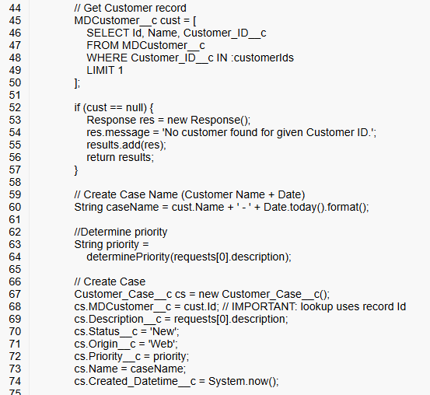
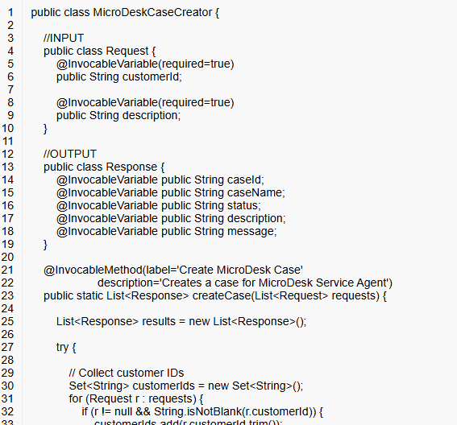

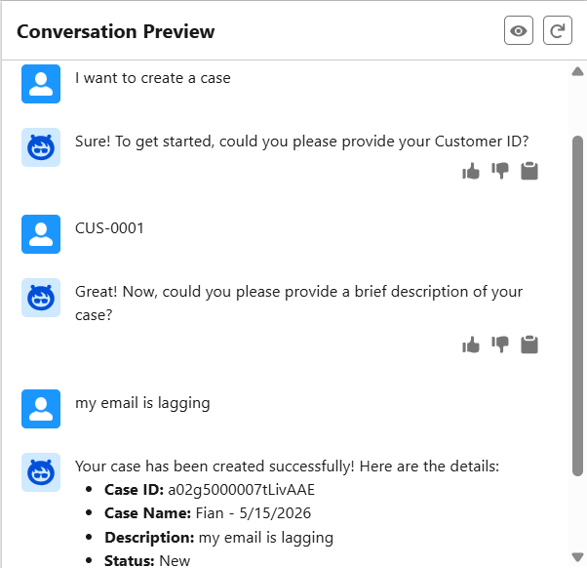

Description of 5(d): The goal of the MicroDesk Service Agent, in this case, is to create a case given a description and the customer ID by the user. Like that assigning some of its fields like origin à web, status à new, created date/time à NOW(), and the case name à customer name (retrieved through the customer ID) and the date so TODAY(). For the agent to do this, an Invocable Method was created to retrieve the customer ID and case description, catching exceptions as if the user does not provide the customer ID, if the customer ID is not found and if the creation of the case is successful. Then, the method was added as an action and assigned as a new topic for the agent to handle. In the implementation evidence, it is visible how: It show the information required, so case ID, Name as formatted, description and status.

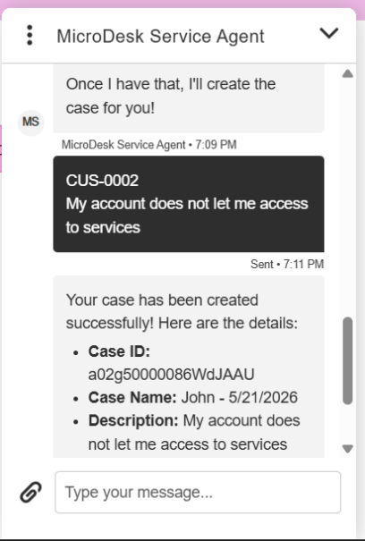
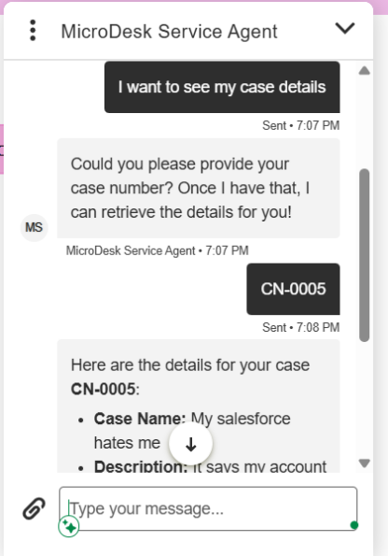
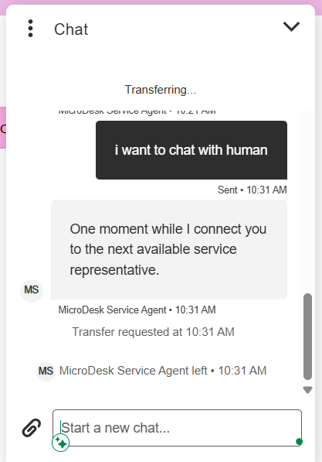
Task 6: Experience Cloud Site
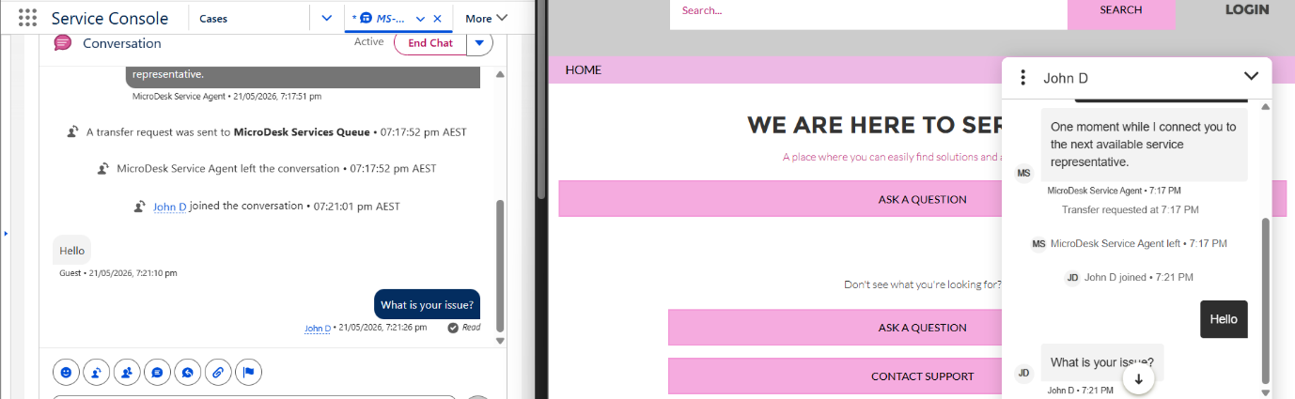
Description of Experience Cloud Site Task: A default Customer Service portal site for MicroDesk Solutions was created with an enhanced bot chat, where the MicroDesk Service Agent was deployed, enabling users to view case details and create new cases by interacting with it as shown in the implementation evidence. Additionally, it redirects the user to a human agent if requested; indeed, above it can be seen a split screen between what the user will see while interacting with the real agent and the service console from which the agent will take the messages.

Task 7: Apex REST Webservice
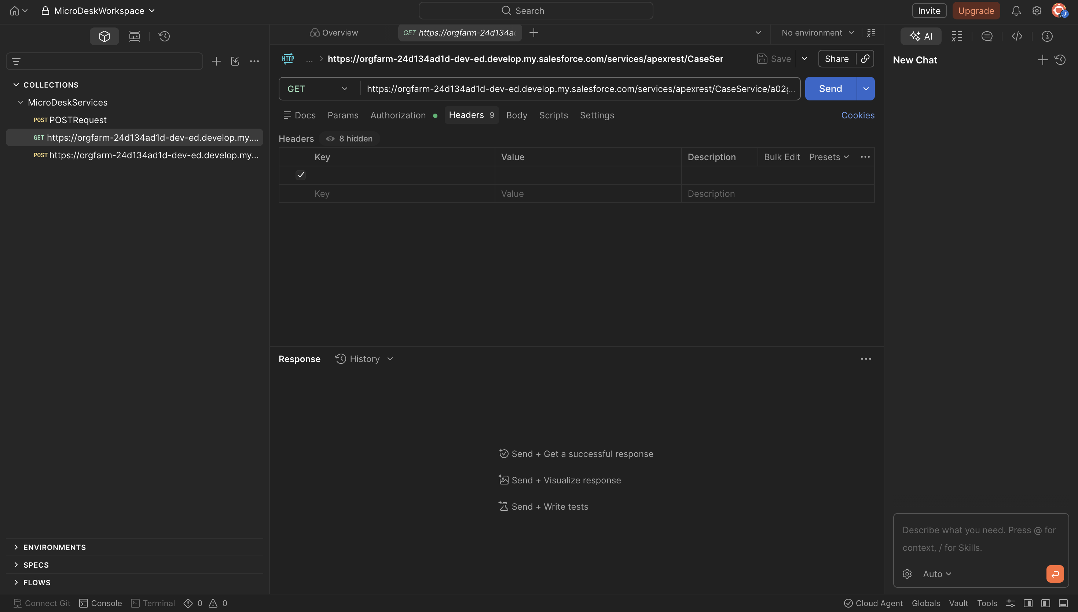
Code:
@RestResource(urlMapping='/CaseService/*) global with sharing class CaseRestService {
@HttpGet
List<Customer_Case__c> caseList = [
SELECT Id, Name, MDCustomer__c, Case_Number__c,
Created_Datetime__c, Category__c, Status__c,
Priority__c, Resolution_Note__c, Escalated__c
FROM Customer_Case__c
WHERE Id = :caseId
];
if (caseList.isEmpty()) {
return null;
}
Customer_Case__c c = caseList[0];
CaseWrapper wrapper = new CaseWrapper();
wrapper.caseName = c.Name;
wrapper.customer = c.MDCustomer__c;
wrapper.caseNumber = c.Case_Number__c;
wrapper.dateCreated = c.Created_Datetime__c;
wrapper.category = c.Category__c;
wrapper.status = c.Status__c;
wrapper.priority = c.Priority__c;
wrapper.resolutionNote = c.Resolution_Note__c;
wrapper.escalation = c.Escalated__c;
return wrapper;
}
@HttpPost global static String createCustomer( String firstName, String lastName, String email, String phone, String address, String customerType, String organizationName ) { MDCustomer__c newCustomer = new MDCustomer__c(); newCustomer.Name = firstName; newCustomer.Last_Name__c = lastName; newCustomer.Email__c = email; newCustomer.Phone__c = phone; newCustomer.Address__c = address; newCustomer.Customer_Type__c = customerType; newCustomer.Organization_Name__c = organizationName;
insert newCustomer;
return 'Customer created successfully. ID: ' + newCustomer.Id;
}
global class CaseWrapper {
global String caseName;
global String customer;
global String caseNumber;
global DateTime dateCreated;
global String category;
global String status;
global String priority;
global String resolutionNote;
global Boolean escalation;
}
}
Description of Apex REST Webservice Task: An Apex REST Webservice in Salesforce that can be accessed through Postman was created, and it supports GET and POST as HTTP methods. The GET method helps retrieve a Case record using Case ID and returns its details, such as Case Name, MDCustomer, Status, Priority, etc. Meanwhile, the POST method allows to create a new MDCustomer by sending First Name, Last Name, Email, Phone, Address and Customer Type. So, overall it focuses on building and testing API endpoints using Apex in Salesforce.

